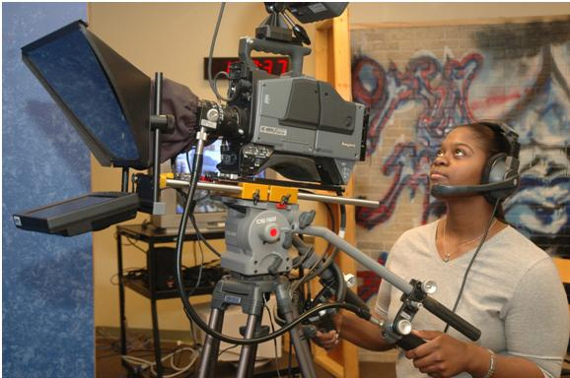

# 

# COURSE

# DESCRIPTIONS

|  |  |
| --- | --- |
| [Accounting](accounting.html)  [Albany State University](asu.html)  [Arts](arts.html)  [Biology](biology.html)  [Business Administration](businessAdmin.html)  [Business Information System & Education](businessInfoSys.html)  [Chemistry](chemistry.html)  [Computer Science](computerScience.html)  [Cooperative Education](cooperativeEdu.html)  [Criminal Justice](criminalJustice.html)  [Learning Support Courses](learningSupport.html)  [Driver Education](driverEdu.html)  [Early Childhood Education](earlyChildEdu.html)  [Economy](economy.html)  [Education](education.html)  [Engineering](engineering.html)  [English](english.html)  [Enterpreneurship](enterpreneurship.html)  [Finance](finance.html)  [Fine Arts](fineArts.html)  [Forensic Science](forensicScience.html)  [French](french.html)  [Geography](geography.html)  German  Health Education  History  Honors | Interdisciplinary Natural Science  Journalism  [Logistics](logistics.html)  [Management](management.html)  [Management Healthcare Adminstration](managementHealthcareAdmin.html)  [Marketing](marketing.html)  [Mass Communication](massComm.html)  [Mathematics](math.html)  [Media Education](mediaEdu.html)  [Middle Grade Education](middleGradeEdu.html)  [Military Science](militarySci.html)  [Modern Langauge](modernLang.html)  [Music](music.html)  [Nursing & COHP Courses](nursing.html)  [Philosophy](philosophy.html)  [Physical Education](physicalEdu.html)  [Physics](physics.html)  [Politica Lscience](politicalSci.html)  [Psychology](psychology.html)  [Recreation](recreation.html)  [Social Science](socialSci.html)  [Social Work](socialWork.html)  [Sociology](sociology.html)  [Spanish](spanish.html)  [Special Education](specialEdu.html)  [Speech & Theatre](speechTheatre.html)  [Theatre](theatre.html) |